23CSE202 DATABASE MANAGEMENT SYSTEMS
S3 B.Tech CSE
Department of Computer Science and Engineering
Amrita School of Computing, Amritapuri Campus

3. Database Design Document

Group No : C3
Team Members :
Roll No | Student Name
AM.SC.U4CSE25239 | Nithish Kumar S
AM.SC.U4CSE25253 | Sujeeth S
AM.SC.U4CSE25259 | Yaksh Chouhan
AM.SC.U4CSE25262 | Nithilan S

Project Title : E-Commerce Database Management System

3.1. Detailed description of the project
CartLedger is a centralized e-commerce platform designed to manage online product browsing, shopping carts, and order processing. The system supports two primary users: Customers and Administrators. Customers authenticate to browse a catalog categorized into segments, add items to their shopping cart, and place orders. Administrators manage the system by adding new products, updating stock levels, and tracking order statuses.
Business Rules:
- A user is identified by a unique Email and Role (admin or customer).
- A product must belong to exactly one category, but a category can contain many products.
- A customer can place multiple orders, and each order must contain at least one product.
- Stock quantities must be dynamically updated upon order placement to prevent negative inventory.
- Shopping carts are session-specific and hold temporary product quantities before checkout.

3.2. ER Diagram

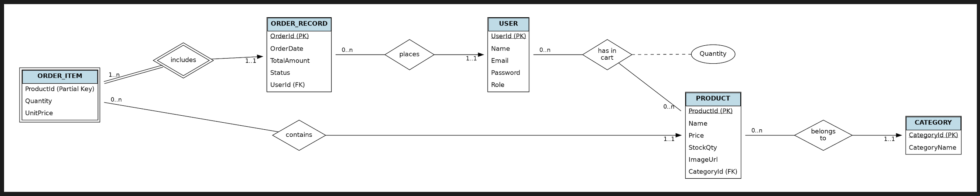
3.3 Relational Schema

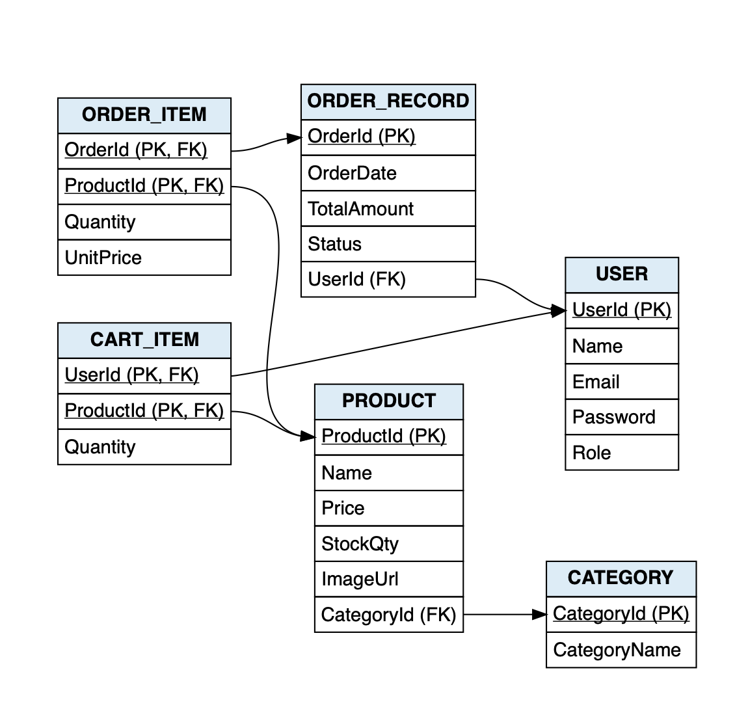

3.4 Normalization and Functional dependency analysis
Functional Dependencies (FDs):
- Users: {UserId} → {Name, Email, Password, Role}.
- Categories: {CategoryId} → {CategoryName}.
- Products: {ProductId} → {Name, Price, StockQty, ImageUrl, CategoryId}.
- Orders: {OrderId} → {OrderDate, TotalAmount, Status, UserId}.
- OrderItems: {OrderId, ProductId} → {Quantity, UnitPrice}.
- CartItems: {UserId, ProductId} → {Quantity}.
Candidate Keys & Attribute Closure: For Products, the attribute closure for {ProductId}+ yields {ProductId, Name, Price, StockQty, ImageUrl, CategoryId}. Since it yields all relation attributes, it serves as the primary candidate key. For Users, because emails must be unique for login authentication, the attribute closure for {Email}+ also yields all attributes. Both {UserId} and {Email} serve as candidate keys. For Orders, {OrderId}+ yields all relation attributes, proving it is the primary key.
Normalization Process:
- 1NF (First Normal Form): Achieved by eliminating repeating groups. The multi-valued cart contents and order contents are strictly separated into the CART_ITEM and ORDER_ITEM tables rather than stored as a list inside the USER or ORDER_RECORD entities.
- 2NF (Second Normal Form): Achieved as no partial dependencies exist. In composite key relations like ORDER_ITEM (OrderId, ProductId), attributes like {Quantity, UnitPrice} depend entirely on the combined key, not a single part of it.
- 3NF & BCNF (Boyce-Codd Normal Form): Achieved because every determinant is a candidate key. There are no transitive dependencies; a product's price does not determine its category, nor does a user's role determine the order status. To prevent transitive dependency (ProductId → CategoryId → CategoryName), CategoryName is strictly isolated in its own CATEGORY table.

